H.T No
Regulations:
A18

Sreenidhi Institute of Science and Technology
(An Autonomous Institution)
Code No:7B515 Date: 17-August-2024 (AN)

B.Tech III-Year I- Semester External Examination, August - 2024 (Supplementary)
DESIGN OF MACHINE MEMBERS-I (MECHANICAL)

Time: 3 Hours Max.Marks:70

Note: a) No additional answer sheets will be provided.
b) All sub-parts of a question must be answered at one place only, otherwise it will not be valued.
c) Missing data can be assumed suitably.

Bloom's Cognitive Levels of Learning (BCLL)

Remember | L1 | Apply | L3 | Evaluate | L5
Understand | L2 | Analyze | L4 | Create | L6

Part - A Max.Marks:20
Answer all QUESTIONS

 |  | BCLL | CO(s) | Marks
1 | Classify the static failure theories. | L2 | CO1 | [2M]
2 | Explain the endurance stress | L2 | CO2 | [2M]
3 | Write any two advantages of the sunk key | L1 | CO3 | [2M]
4 | Define spring index | L1 | CO4 | [2M]
5 | List two advantages of bolted joint over riveted joint | L2 | CO5 | [2M]
6 | Explain the strength of the fillet welded joint | L2 | CO6 | [2M]
7 | Discuss the concept of stiffness in tension | L2 | CO1 | [2M]
8 | Differentiate muff and split muff coupling | L2 | CO3 | [2M]
9 | Define the efficiency of the riveted joint | L1 | CO5 | [2M]
10 | Draw the Soderberg line for failure theories. | L2 | CO2 | [2M]
Part – B Max.Marks:50
ANSWER ANY FIVE QUESTIONS. EACH QUESTION CARRIES 10 MARKS.

 |  |  | BCLL | CO(s) | Marks
11. | a) | Explain the Guest’s theory and Hencky’s theory. | L2 | CO1 | [5M]
 | b) | A steel machine part is statically loaded and has yield strength of 320 MPa. For each of the following stress states find the factor of safety using any two static failure theories.  a) σ_{x} = 60 MPa; σ_{y} = -30 MPa; τ_{xy} = 40 MPa  b) σ_{x} = 70 MPa; τ_{xy} = 30 MPa. | L3 | CO1 | [5M]
12. | a) | Explain different fluctuating stresses with neat sketch. | L2 | CO2 | [5M]
 | b) | A simply supported shaft between bearings carries a steady load of 10 kN at the centre. The length of shaft between bearings is 450 mm. Neglecting the effect of stress concentration; find the minimum diameter of shaft. Given that Endurance limit = 600 MPa; surface finish factor = 0.87; size factor = 0.85; and factor of safety = 1.6. | L3 | CO2 | [5M]
13. | a) | Explain the design procedure of knuckle joint | L2 | CO3 | [5M]
 | b) | Design a compression coupling for a shaft to transmit 1300 N-m. The allowable shear stress for the shaft and key is 40 MPa and the number of bolts connecting the two halves are 4. The permissible tensile stress for the bolts material is 70 MPa. The coefficient of friction between the muff and the shaft surface may be taken as 0.3. | L4 | CO3 | [5M]
14. | a) | Derive the expression for Load shared by outer spring and inner spring (W₁/W₂) in terms of diameter of spring wire of outer spring and inner spring in concentric springs. | L2 | CO4 | [5M]
 | b) | A helical spring is made from a wire of 6 mm diameter and has an outside diameter of 75 mm. If the permissible shear stress is 350 MPa and modulus of rigidity 84 kN/mm², find the axial load which the spring can carry and the deflection per active turn. | L3 | CO4 | [5M]
15. | a) | A bracket, as shown in Fig., supports a load of 30 kN. Determine the size of bolts, if the maximum allowable tensile stress in the bolt material is 60 MPa. The distances are: L1 = 80 mm, L2 = 250 mm, and L = 500 mm.  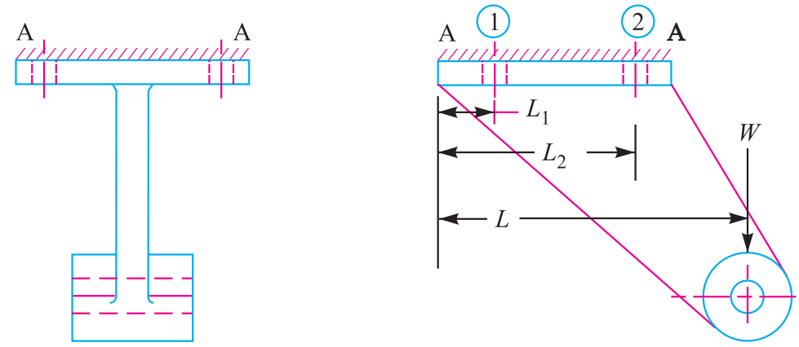 | L3 | CO5 | [5M]
 | b) | Classify the butt riveted joints with neat sketch | L2 | CO5 | [5M]
16. | a) | Write the expression for the tensile strength of the joint for single fillet weld. | L1 | CO6 | [5M]
 | b) | A plate 100 mm wide and 10 mm thick is to be welded to another plate by means of double parallel fillets. The plates are subjected to a static load of 80 kN. Find the length of weld if the permissible shear stress in the weld does not exceed 55 MPa. | L3 | CO6 | [5M]
17. | a) | Explain the manufacturing considerations in design. | L2 | CO1 | [4M]
 | b) | Discuss the factors influencing the endurance limit. | L2 | CO2 | [3M]
 | c) | Write the applications of cotter joint. | L1 | CO3 | [3M]
18. | a) | Explain the design procedure of helical tensile spring. | L2 | CO4 | [4M]
 | b) | Explain the strength of the rivet. | L2 | CO5 | [3M]
 | c) | Explain the eccentrically loaded welded joints. | L2 | CO6 | [3M]

-- 00 -- 00 –

